Current Activities & Acquisitions
We were contacted in June by IBM Oslo to say that, as they are moving offices later in the year, they would like to donate a number of artefacts to the Hursley museum. This turns out to be a treasure trove of time recording and punch card / unit record equipment, together with many other unique items. The IBM Norway manufacturing plant produced time recording equipment from 1952 until 1960, as well as typewriters from the late 50s. At the moment of writing we are trying to work out the funding arrangements for shipping.

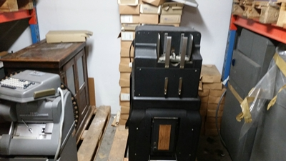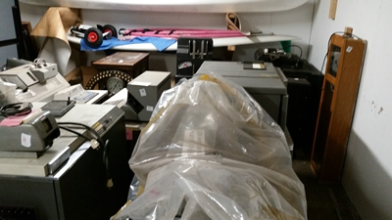

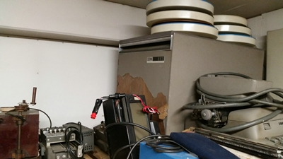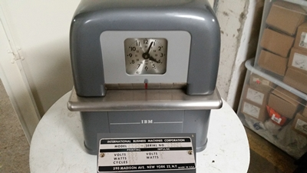

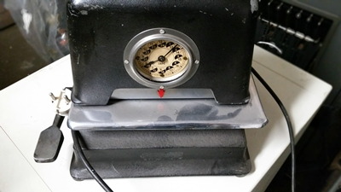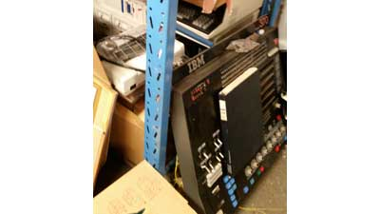

We are now planning to make some changes to the museum layout to accommodate some of these machines as soon as they arrive. Highlights include a 1930s 416 tabulator and 550 interpreter, and 1950s 557 interpreter and 519 reproducing punch. There’s also a 5496, the 96 column card punch released with System/3 in the early 70s, probably the last ever rehash of the punch card.

We have also made some changes to the ThinkPad display. Those of you who have visited Hursley may remember that we had a long rack of ThinkPads. We have cut this down from 5 sections to 2, and used the space for a glass display cabinet and a Sequent server rack. The Sequent is on display as an example of IBM acquiring companies for their technology.

Sequent had developed advanced hardware and software to allow a large number of processors to operate as a single system, with quick scalability to manage unpredictable workloads. However the company was not successfully leveraging the technology. When IBM acquired Sequent in 1999, the company marketed Sequent products and subsequently used it in its own products.

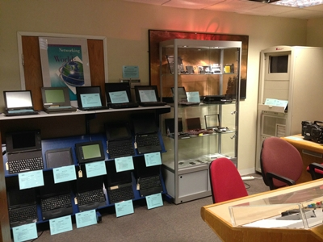

The new display cabinet contains a ThinkPad 701, the ‘Butterfly,’ which has been disassembled. Visitors can see the innards of the laptop including the mechanism that retracted the keyboard. There is also a selection of ThinkPad accessories including a number of PCMCIA cards and the one-inch mini hard disk.

